SOLID Design Principles

Single responsibility Principle- SRP

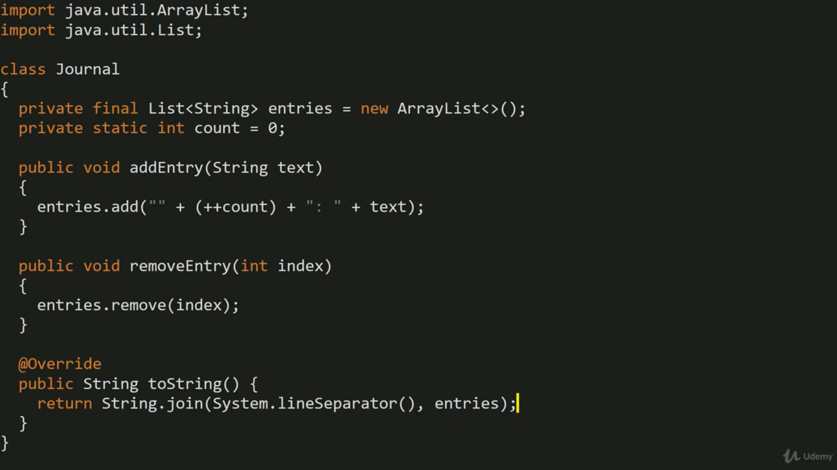

IF we add functionality to save and load journals into same class like shown below its violation of SRP,

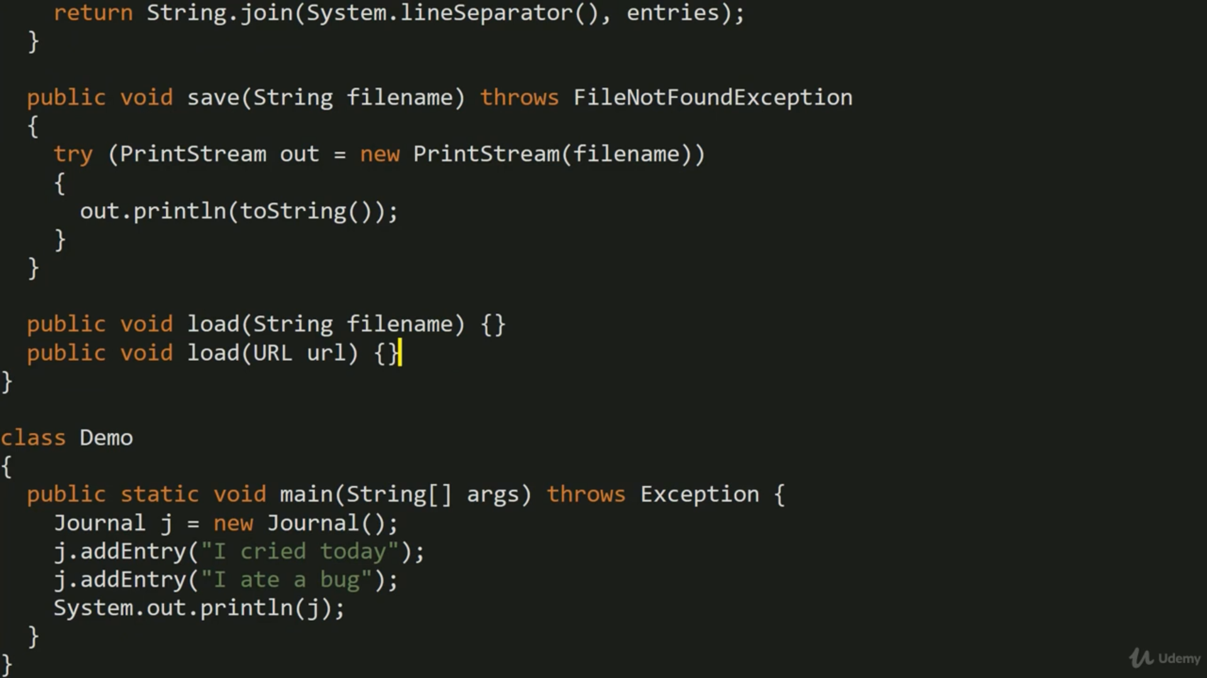

Now to fix above issue, we will separate concerns and we will create new class to handle save/load journals.

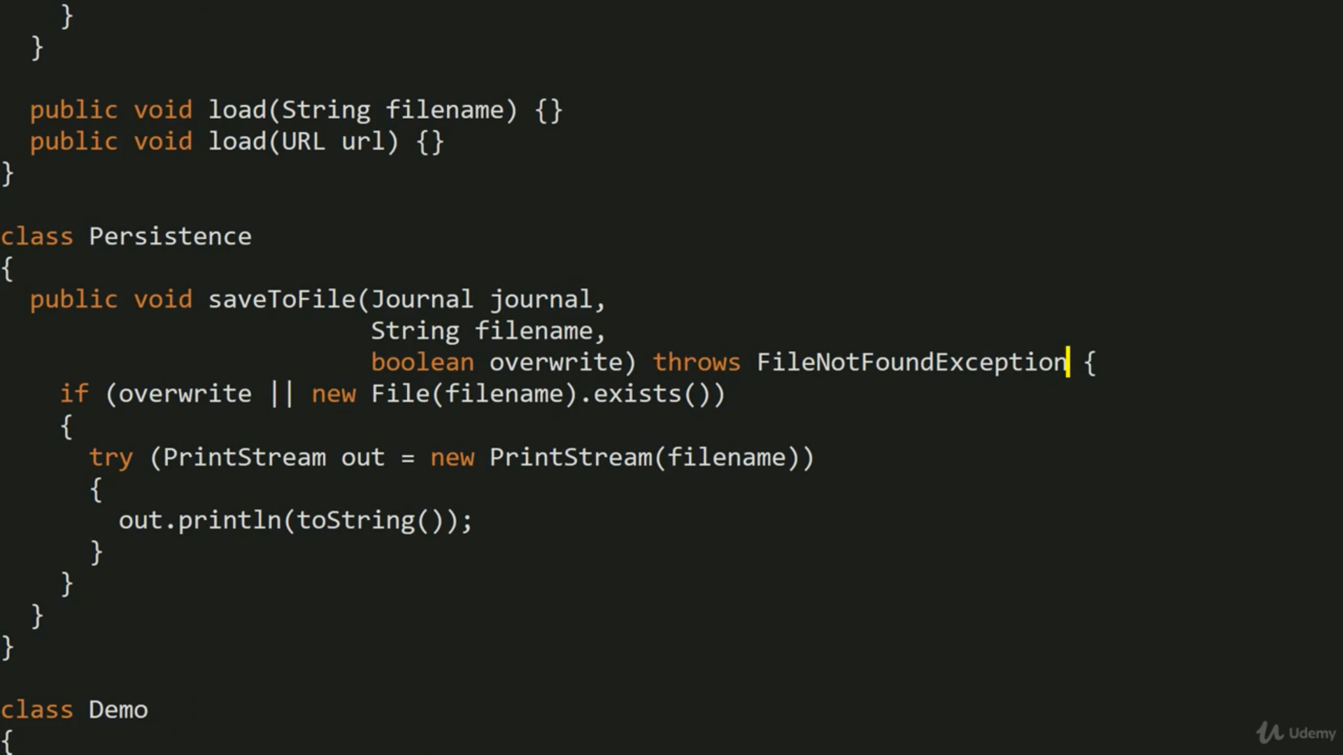

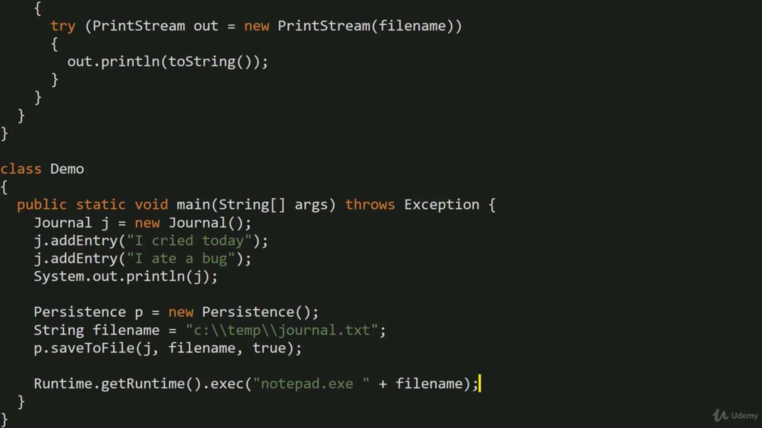

Open Closed Principle- OCP + Specification Design pattern



Open for extension but closed for modification, we are creating filter, but requirement is changing continuously to add new filters,

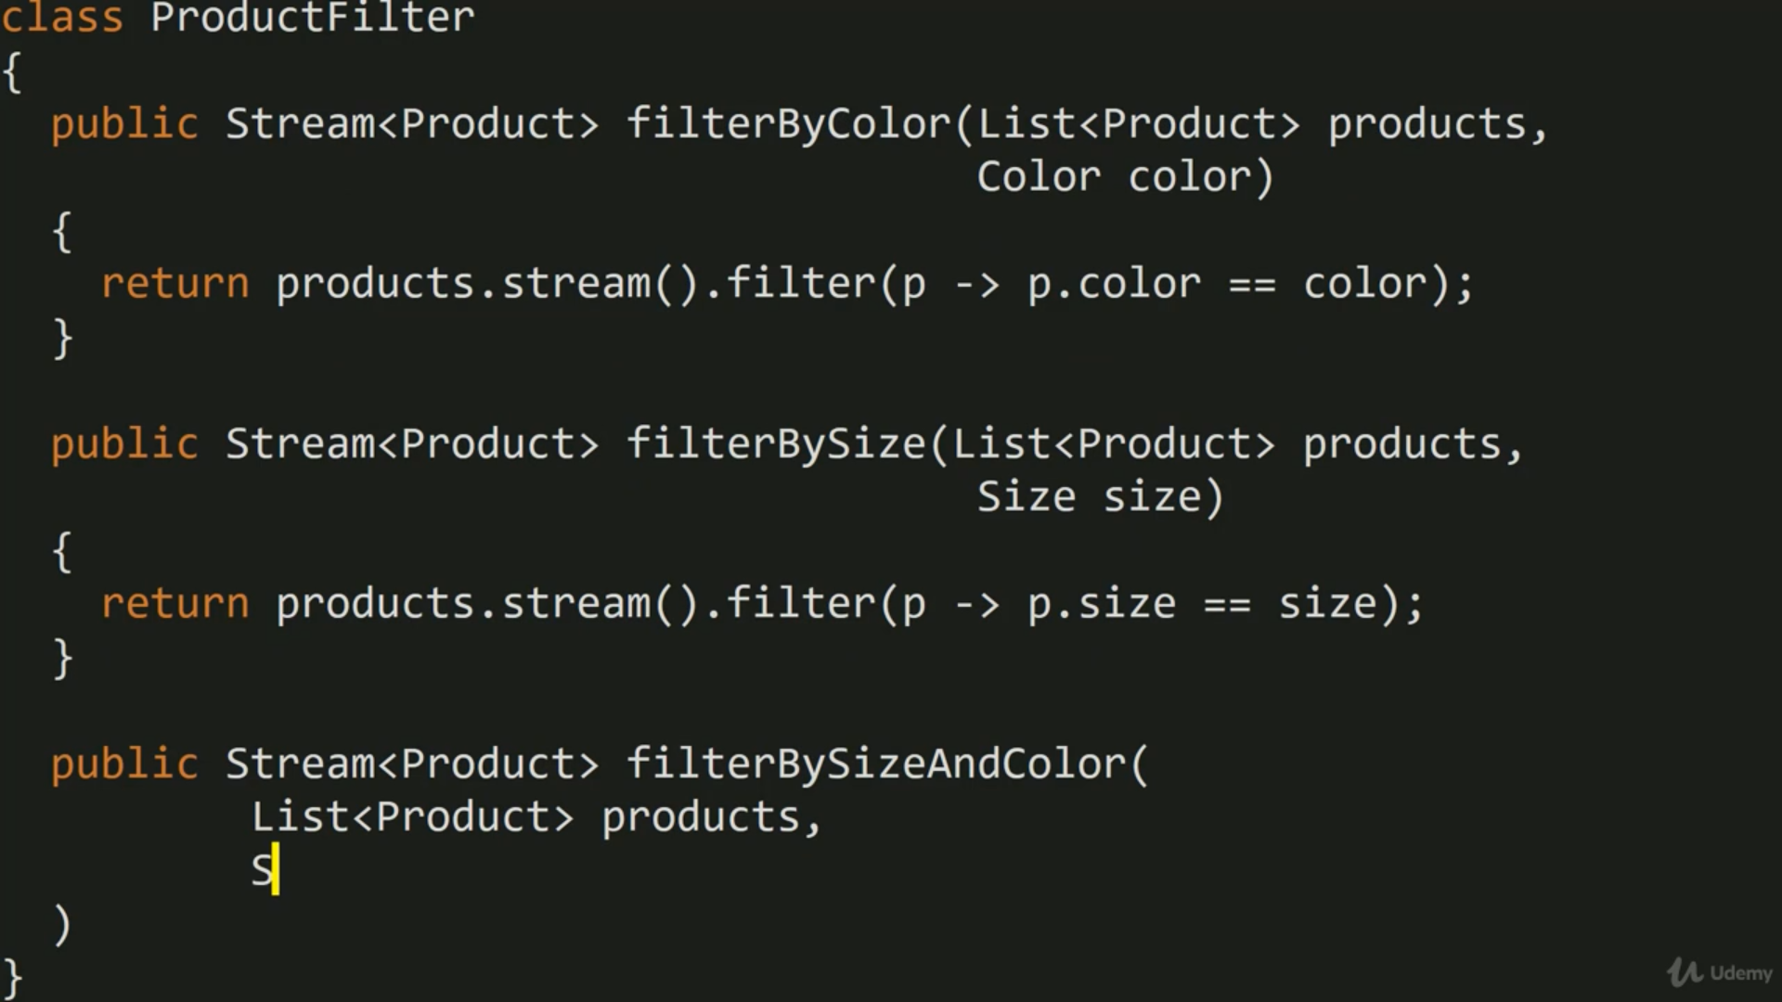

We are using Predicate lambda expression for comparing, predicate is expected in filter function streams.

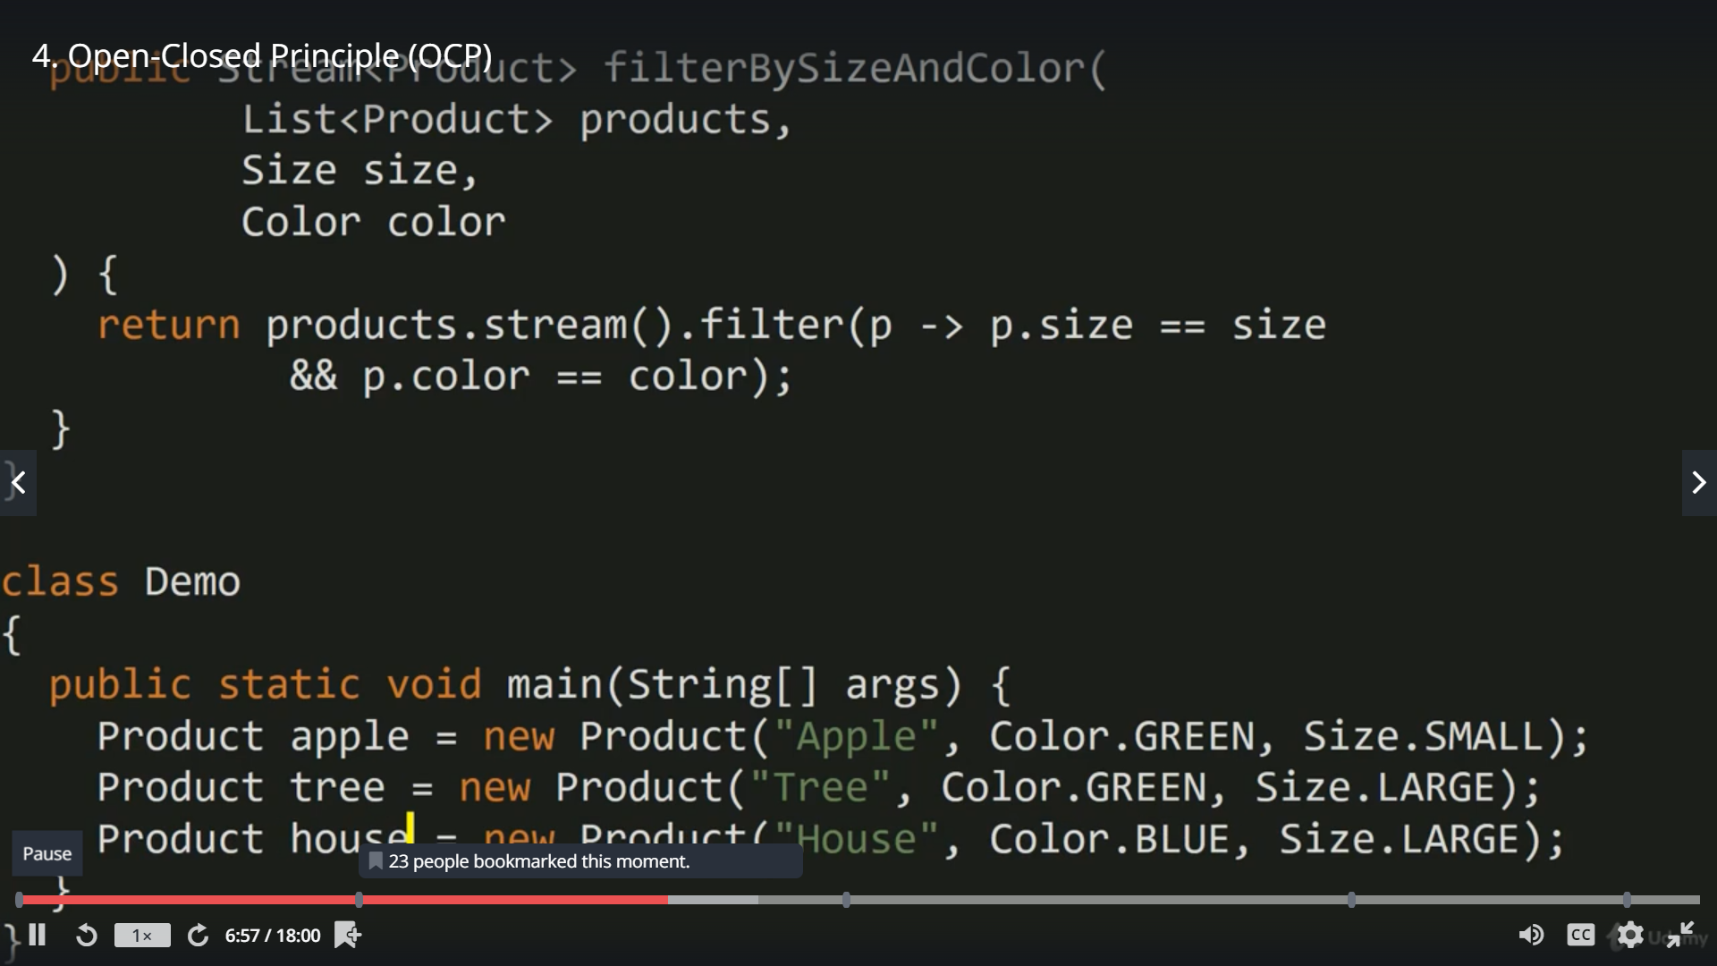

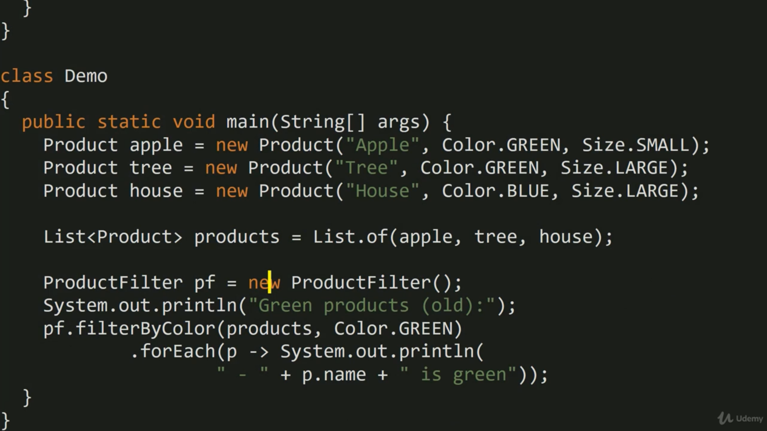

Its working so far but we are violating OCP by modifying the code.

Now let’s fix it and make solution generic,

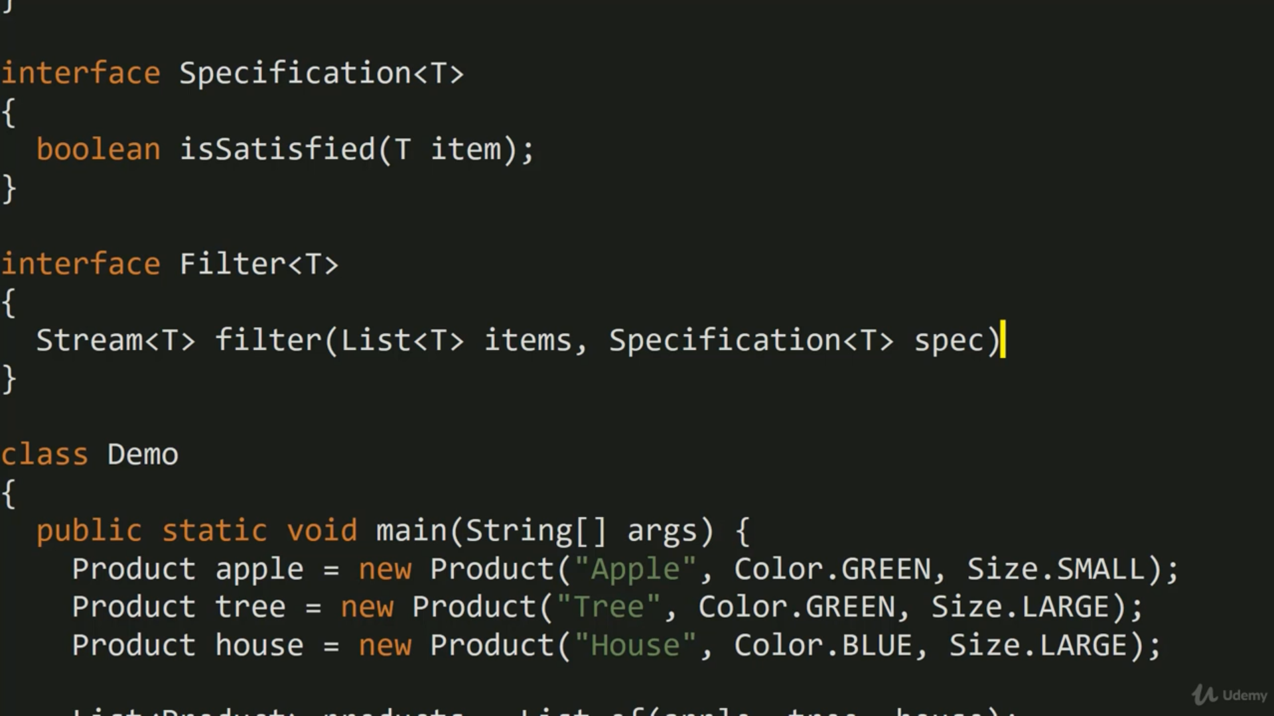

Now let’s implement specification for color and size, to check is particular item i.e product fulfils specification.

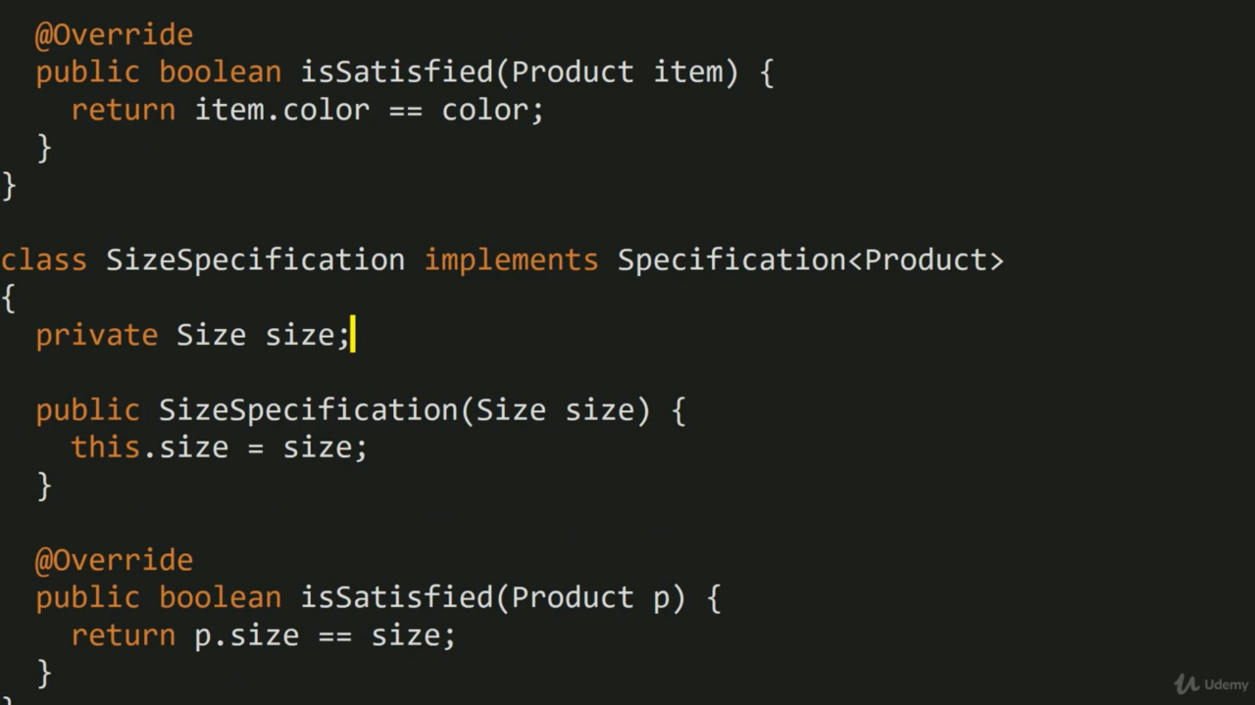

Now let’s implement filter, it takes list of product and specification and filter based on specification.

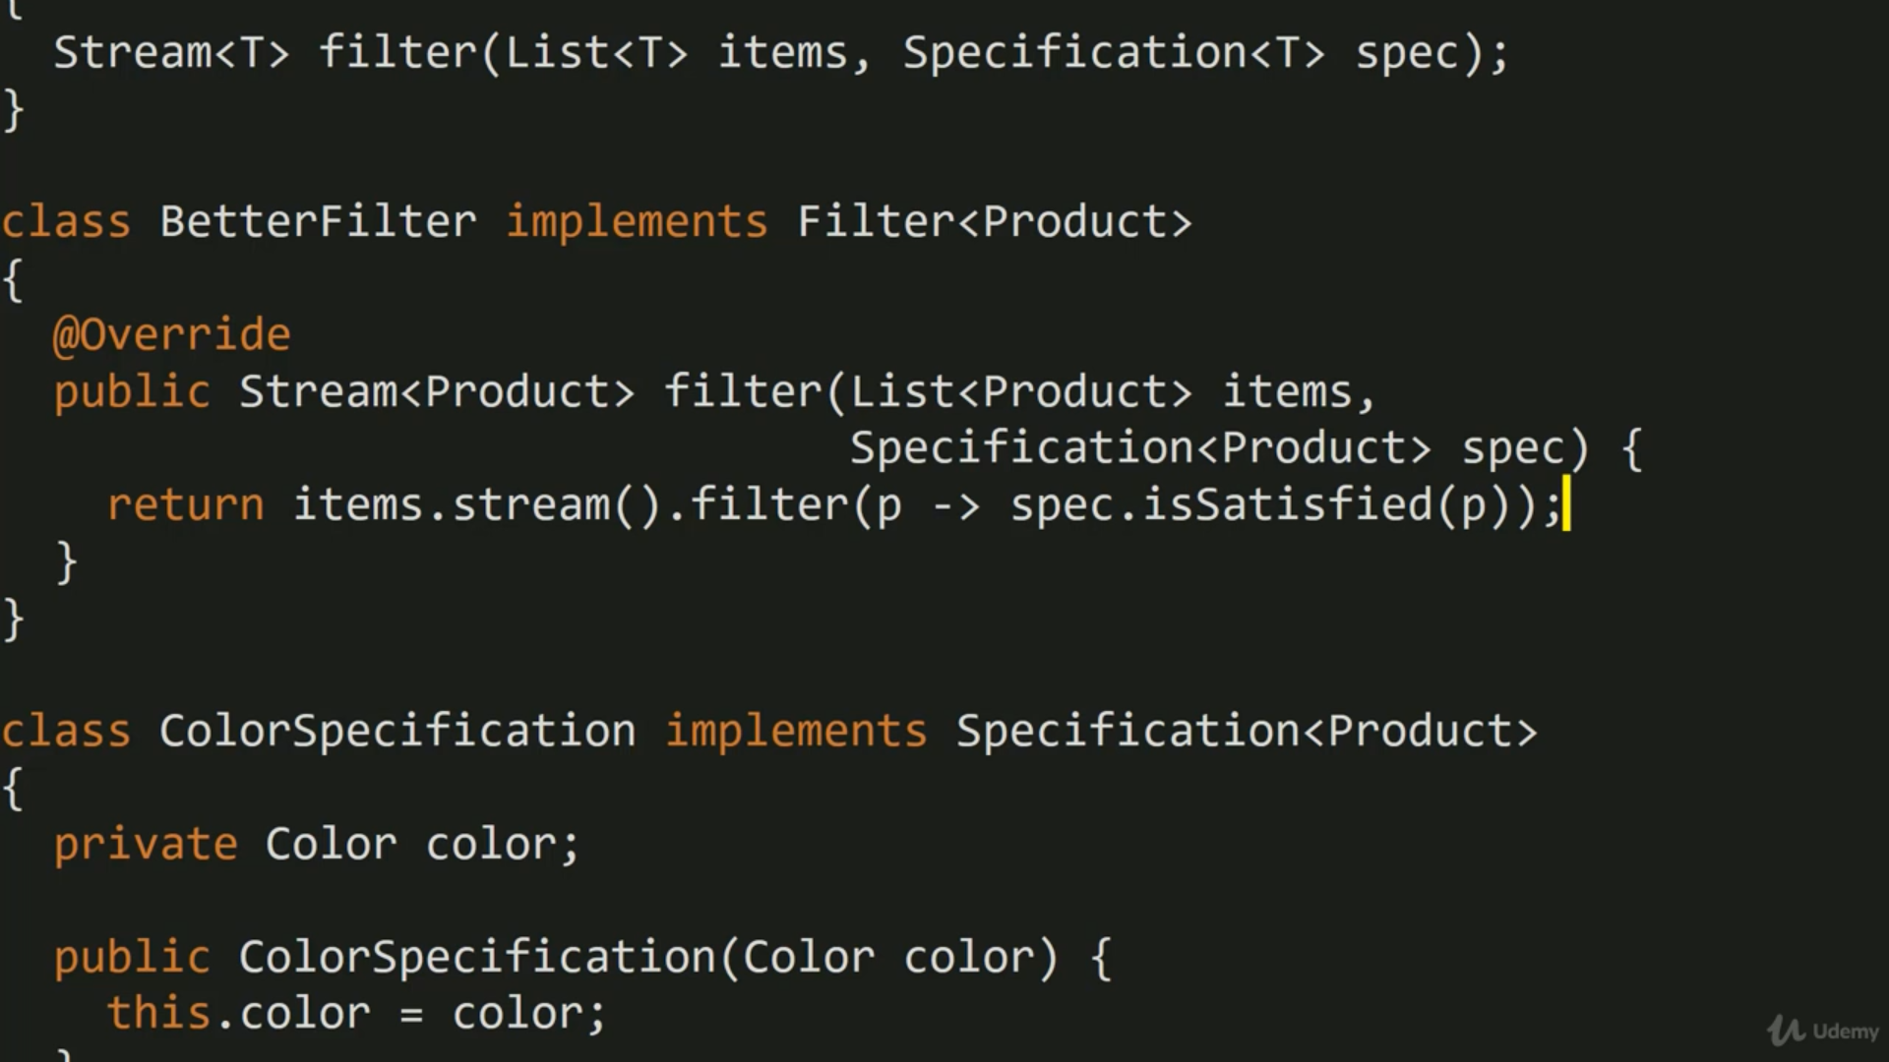

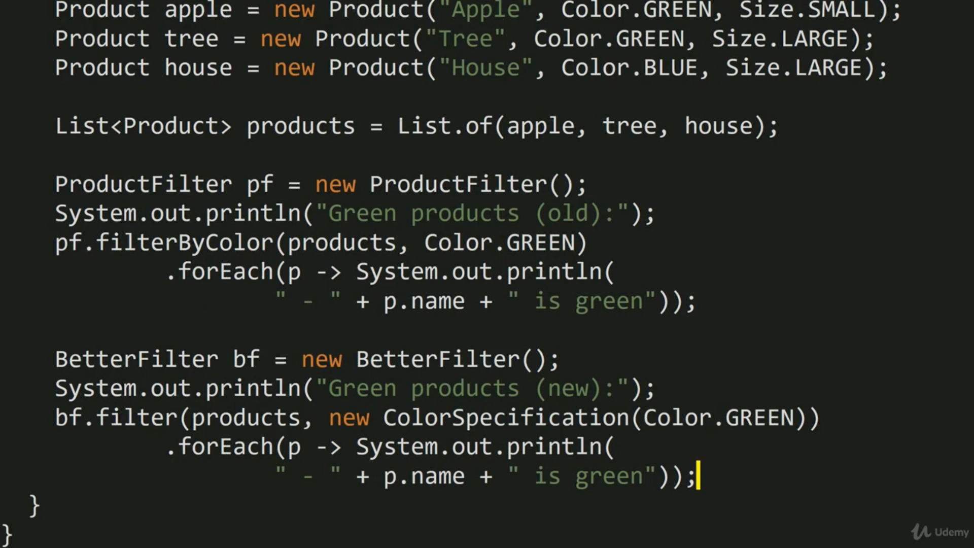

now let implement andspecification to combine 2 specification id both are satisfied.

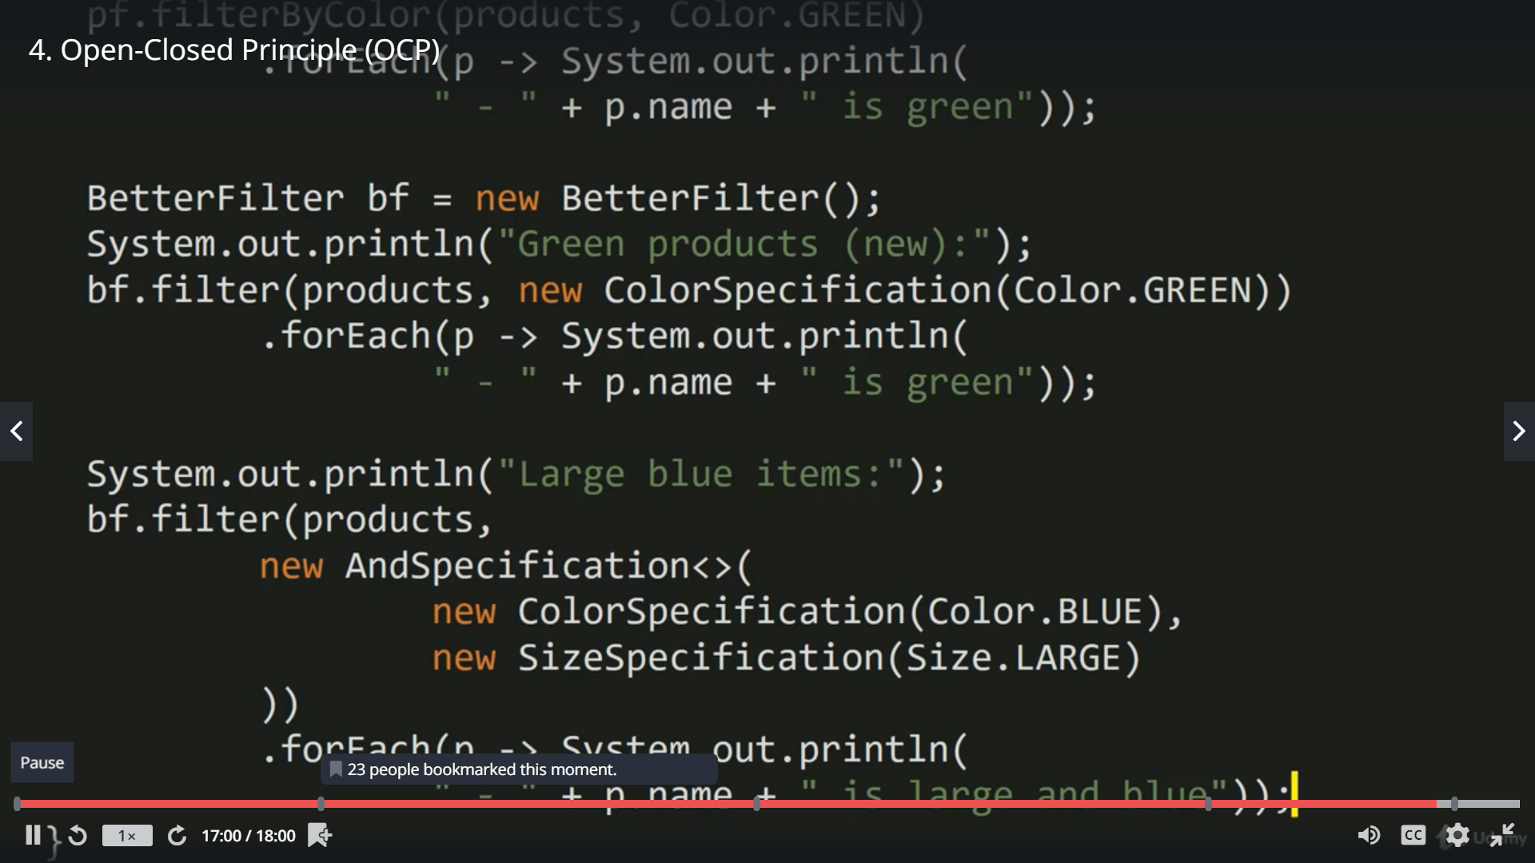

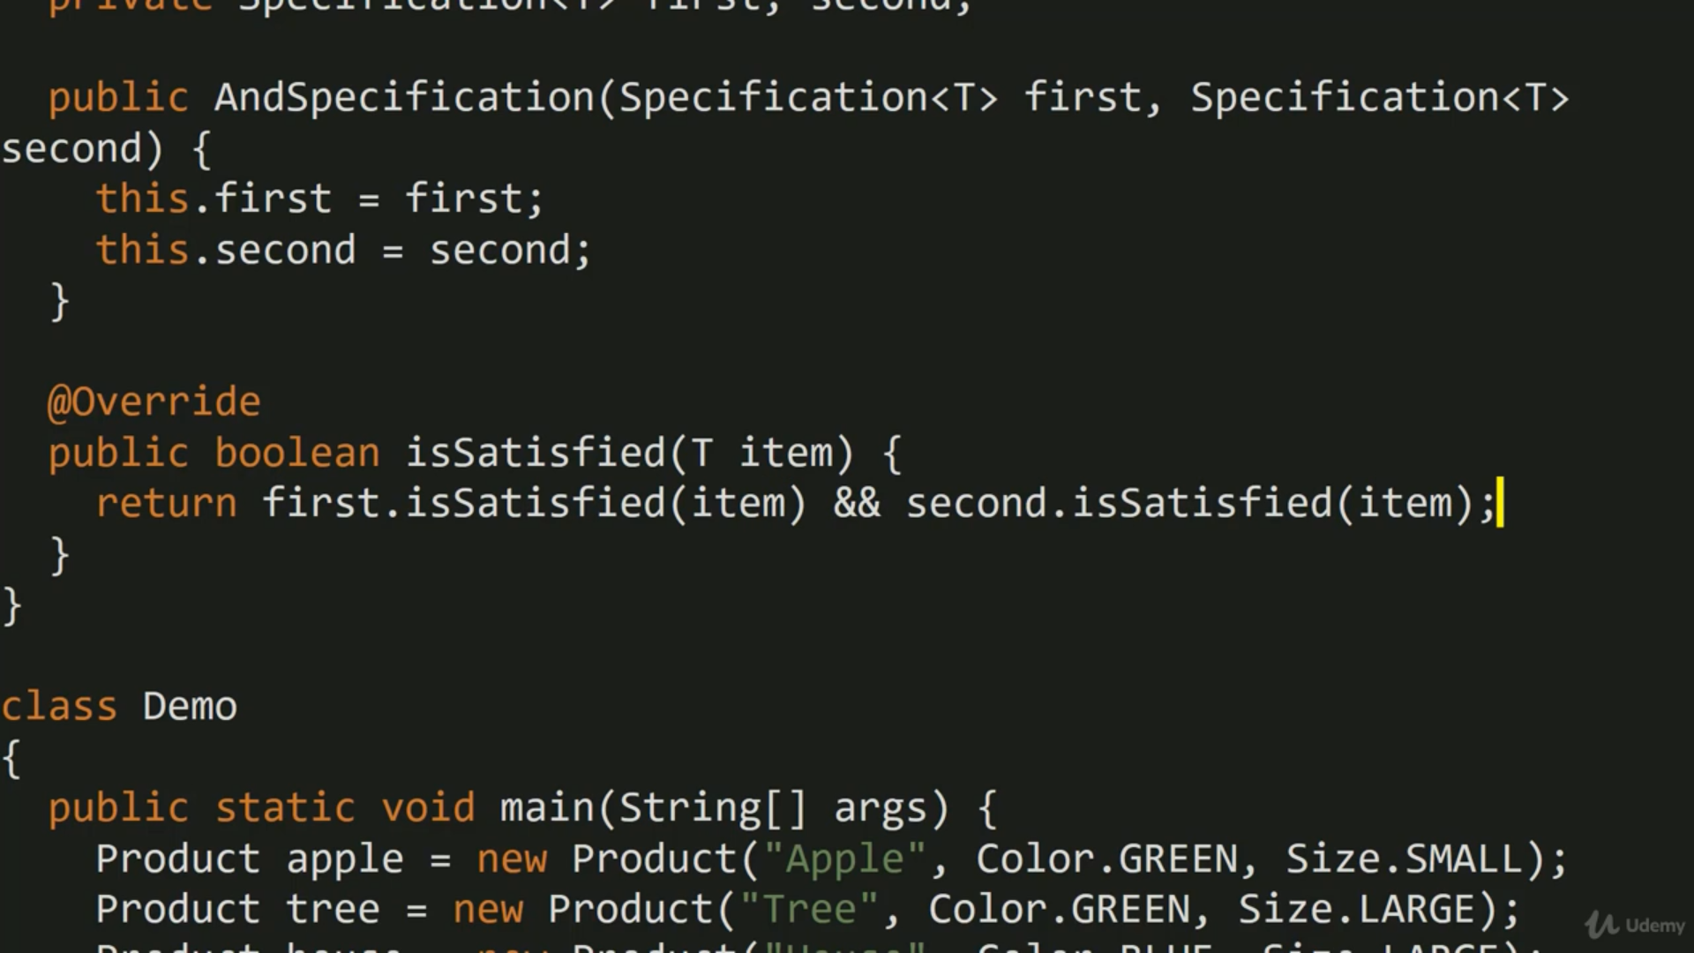

LSP- liskov substitution principle.

It mainly talk about substituting parent class attributes from inherited child class which may cause troubles.

ISP- interface segregation principle.

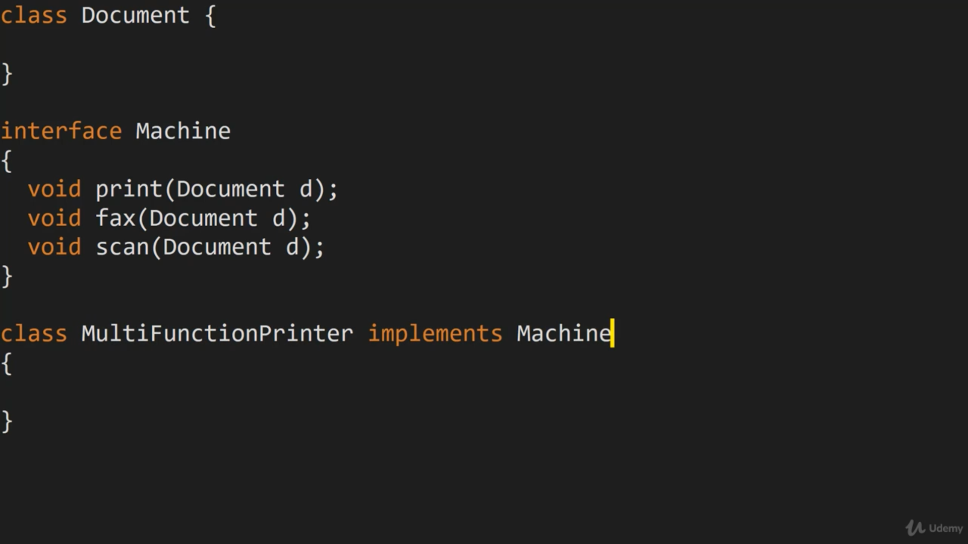

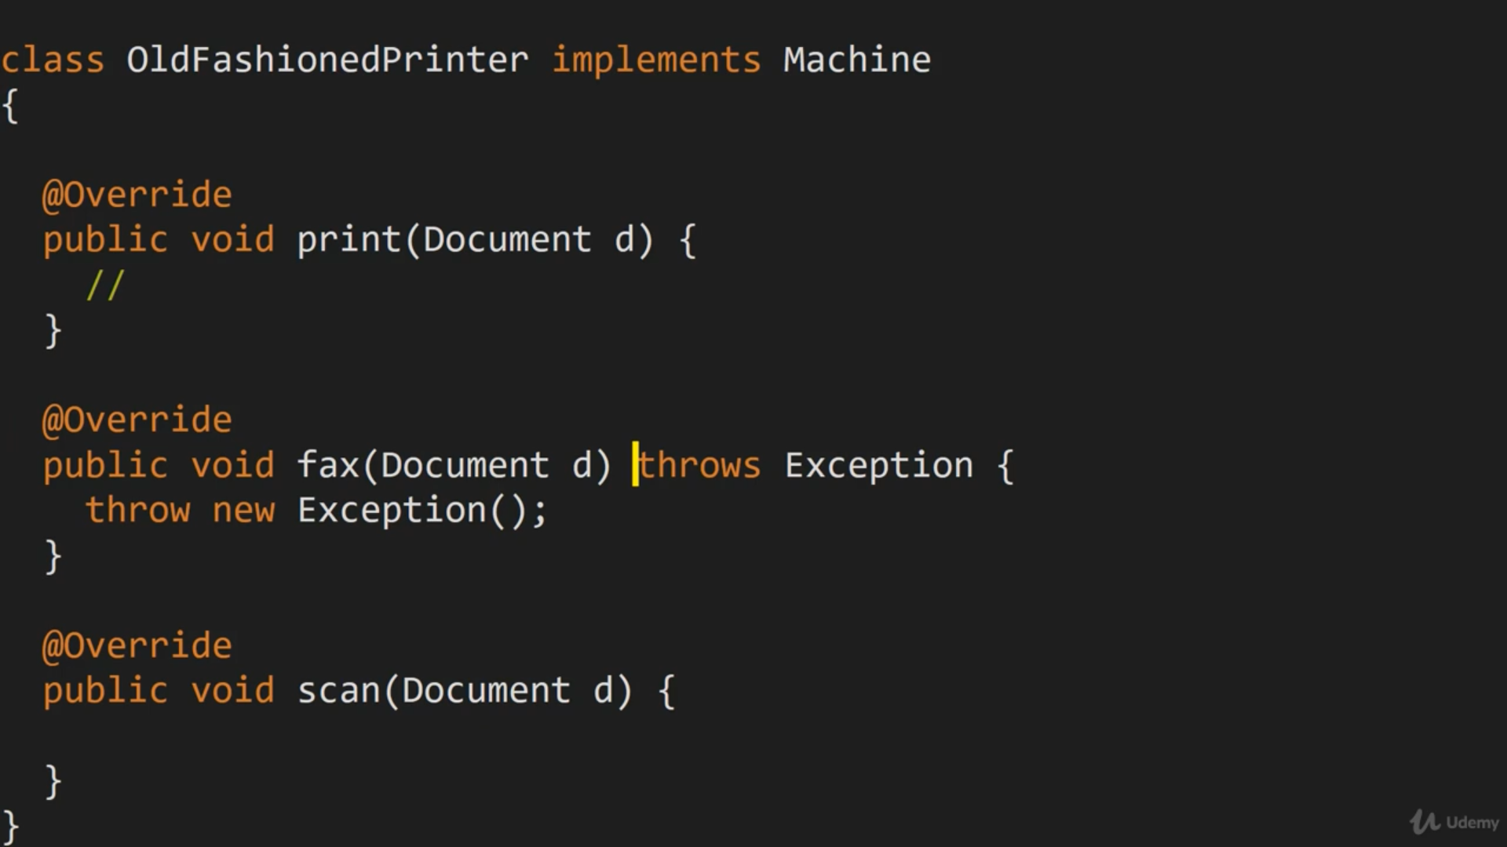

So in old fashion printer implementation, we may not be supporting fax and scan. We may think sending custom exception for not supported as solution in such scenarios but it will add complexity. Clients consuming need to understand these exceptions and unnecessary issues.

Now fix this, with ISP

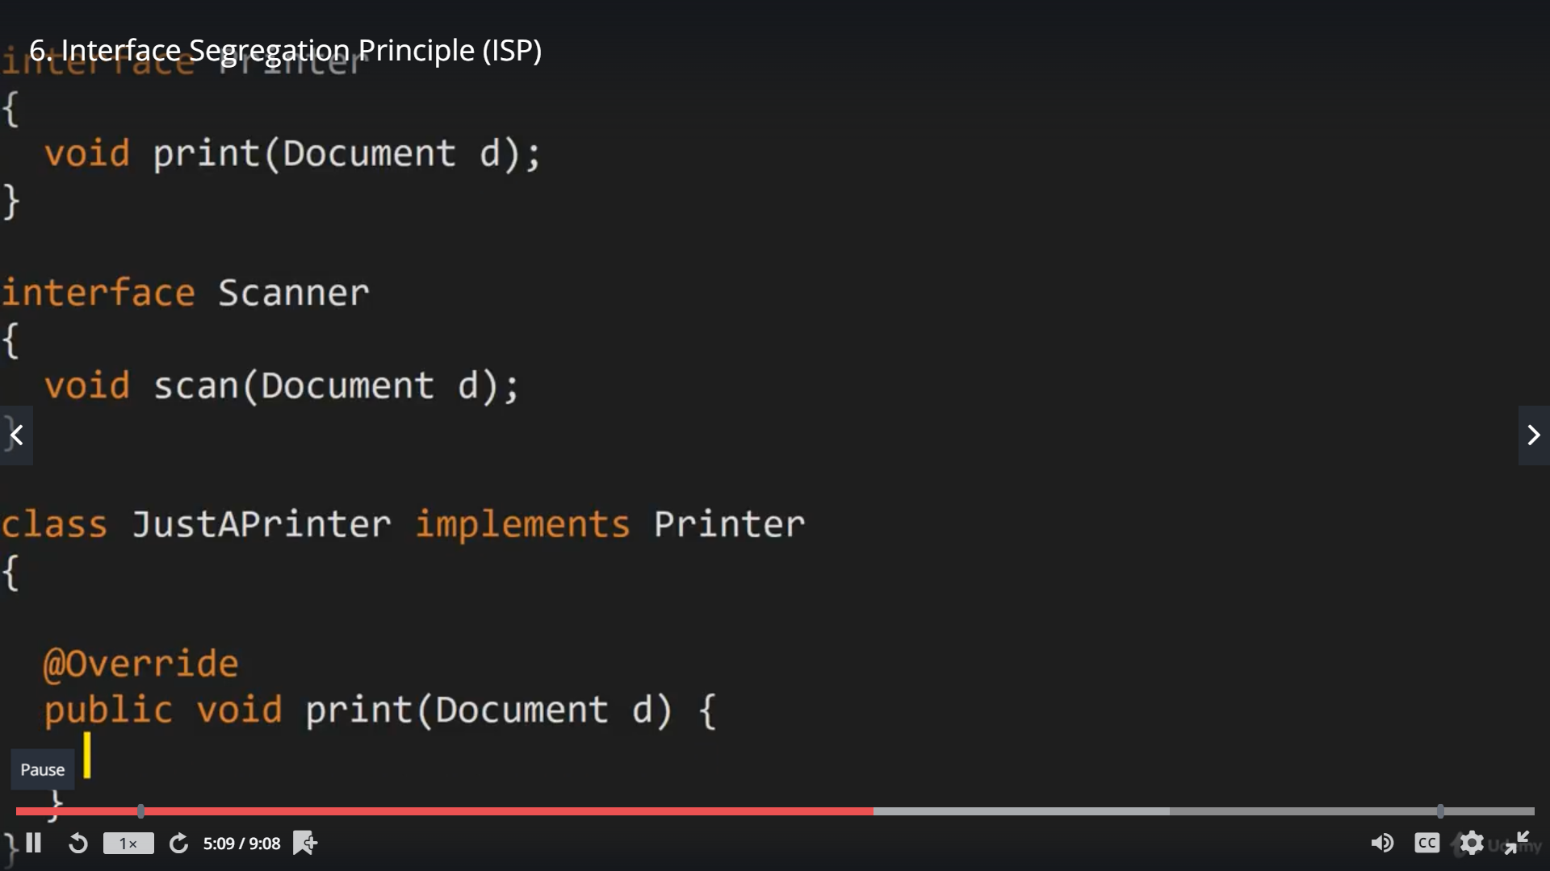

So split interfaces based on responsibility and implement as required, leaving unnecessary implementation by all classes.

DIP- dependency inversion principle – its close but not same as DI.

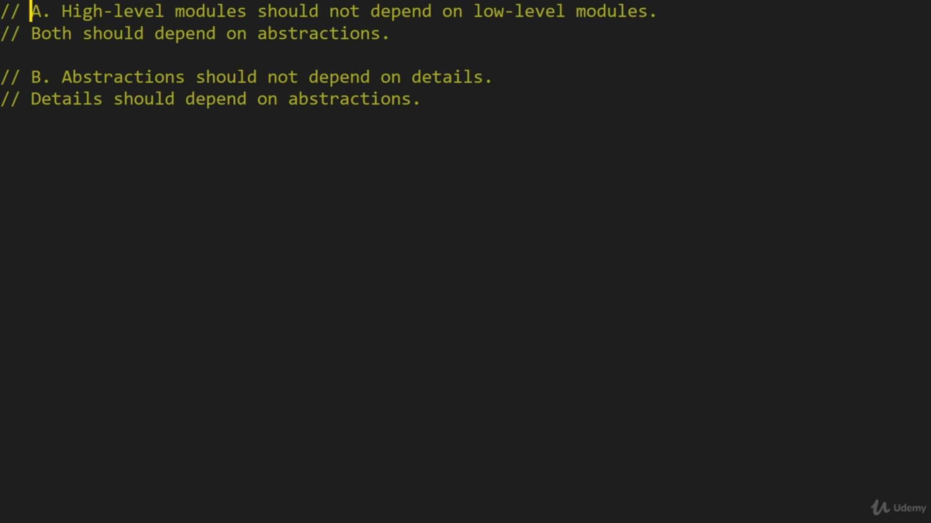

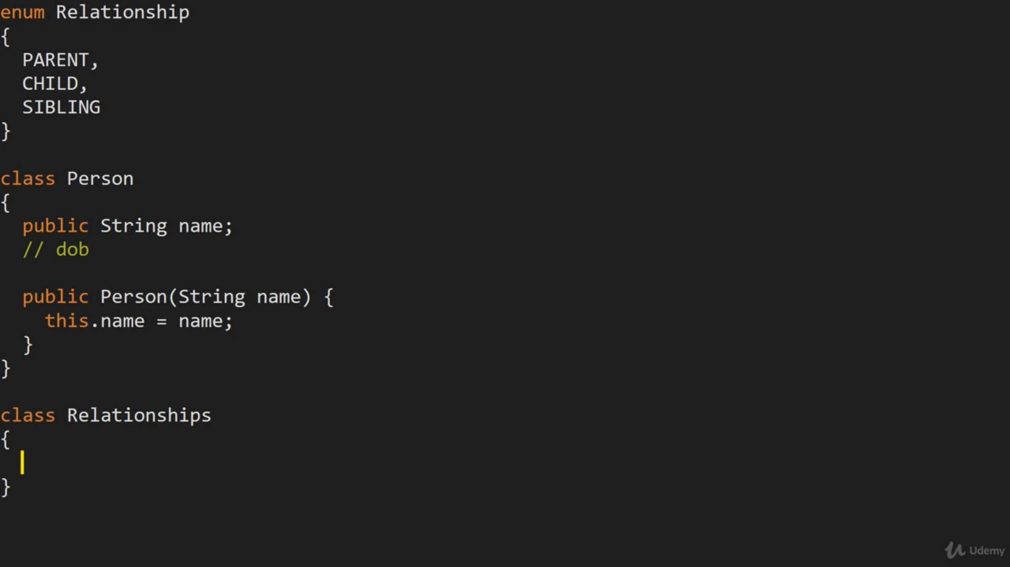

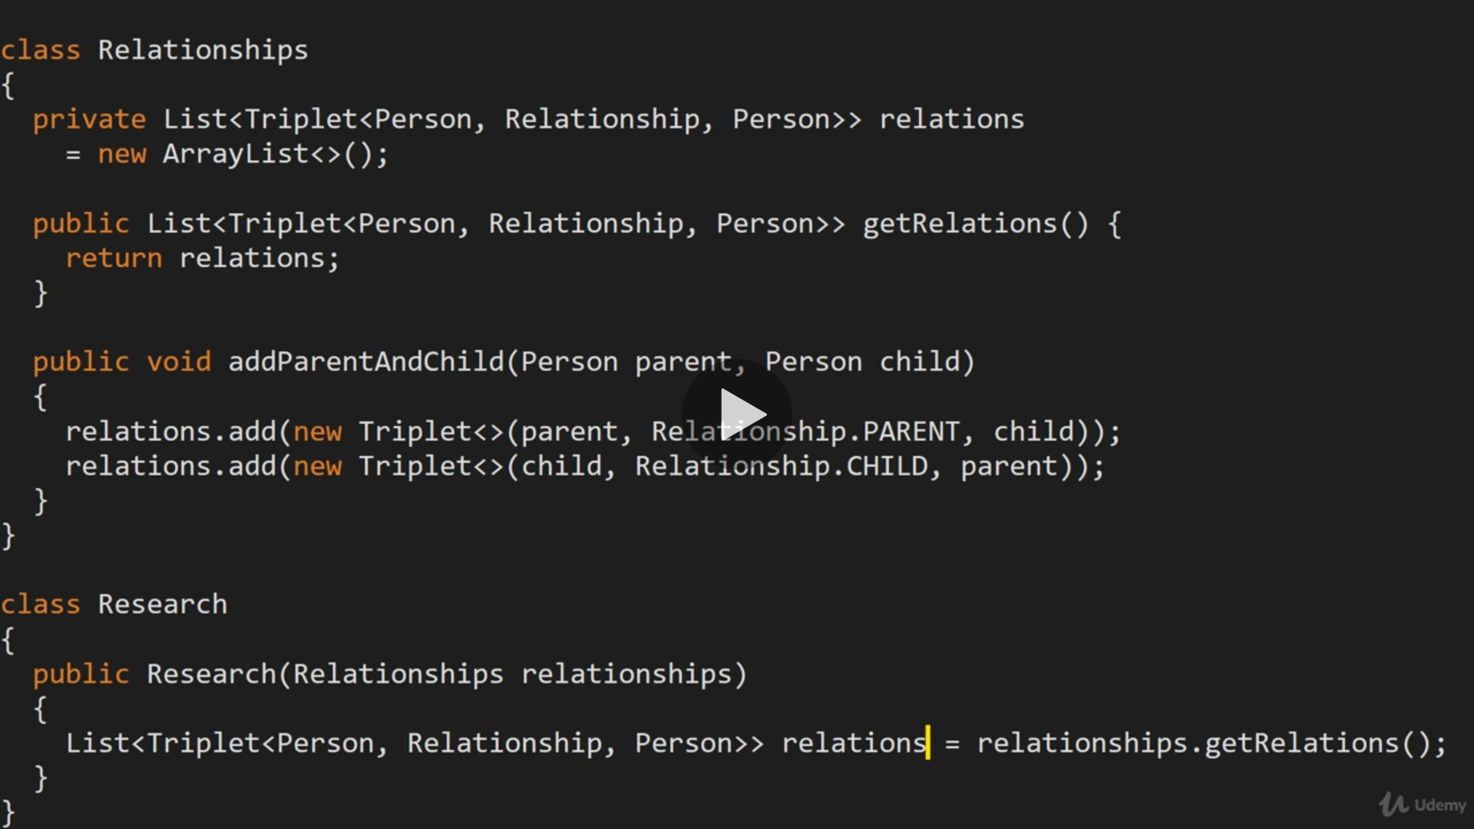

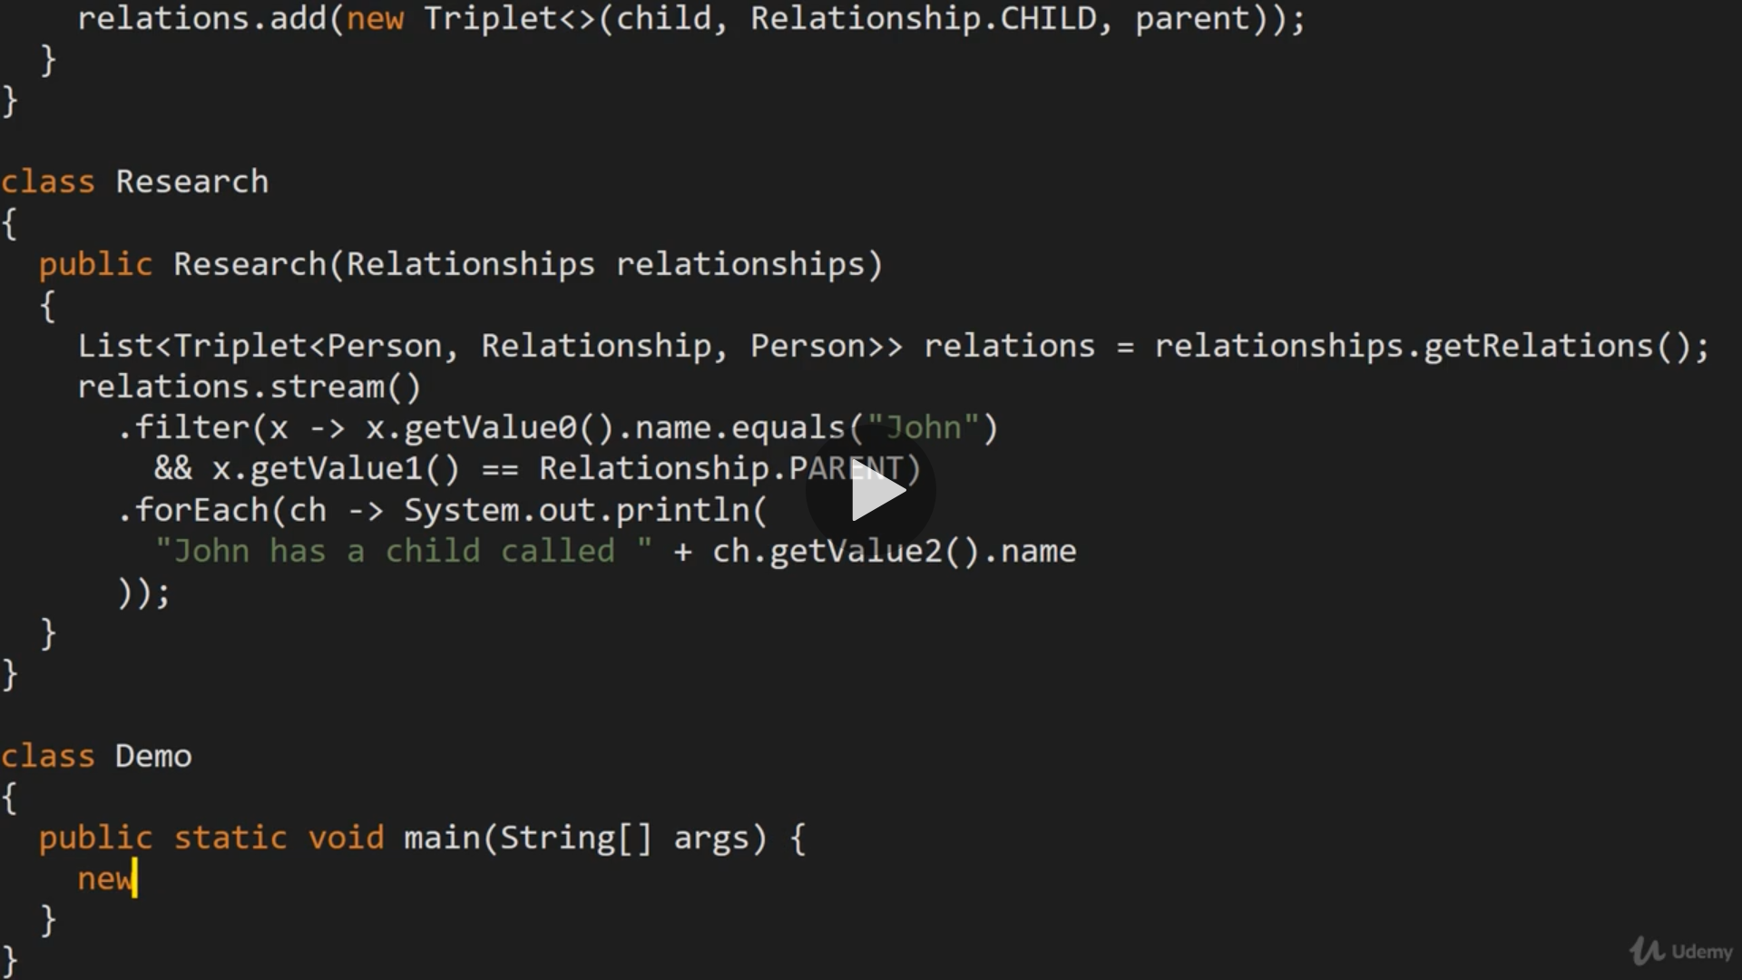

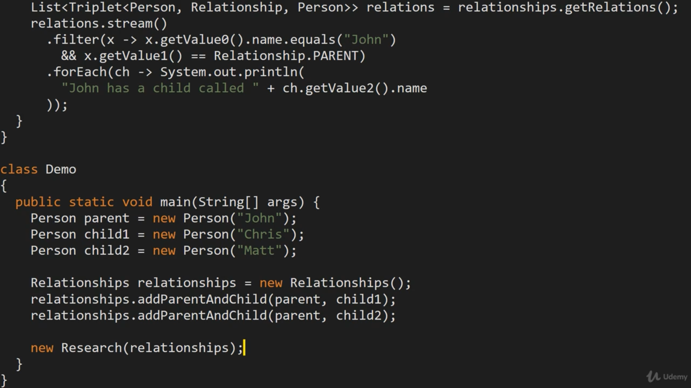

Problems,

Relationsips is low level, its just holding data and no business logic and its sharing data with everyone which is also a problem.

Research is high level as it doing all business logic and interacting with end user to give them results, user don’t bother how/where data is stored.

Highlevel research is tightly coupled and depended on relationships which its getting it in constructor,

Now fix this issue,

Introduce abstractions means interface, move all search code from research which is high level to low level and later point of time data structure may change, then high level need to update code to process data,

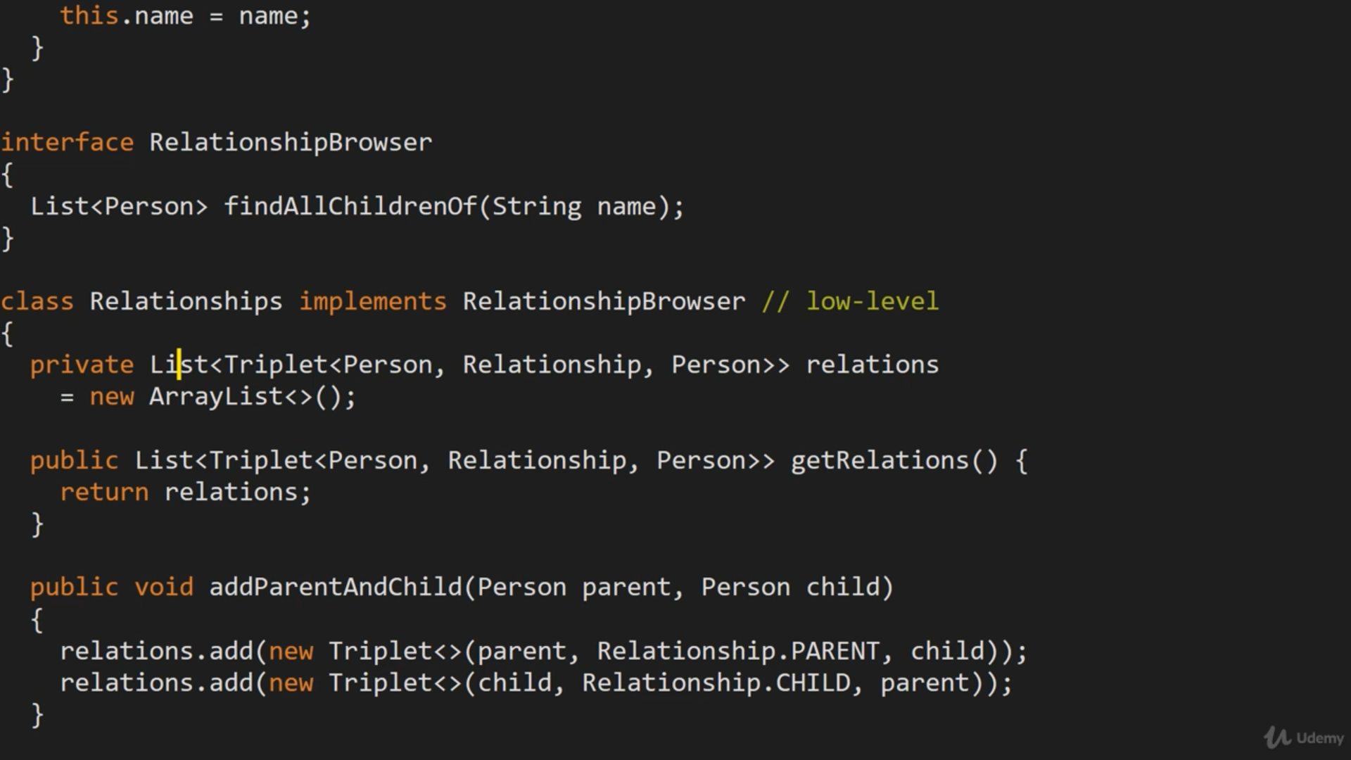

Update research to accept interface and call interface methods, instead of concrete class constructer, which need t be removed.

